**Project Design Phase-II Technology Stack (Architecture & Stack)**

|  |  |
| --- | --- |
| Date | 22October 2022 |
| Team ID | PNT2022TMID51213 |
| Project Name | AI BASED DISCOURSE FOR BANKING INDUSTRY |
| Maximum Marks | 4 Marks |

**Technical Architecture:**

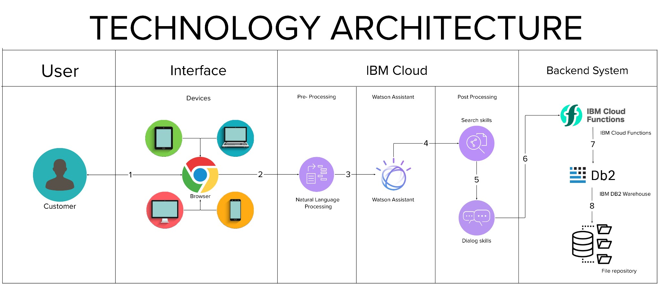

**Table-1 : Components & Technologies:**

|  |  |  |  |
| --- | --- | --- | --- |
| **S.No** | **Component** | **Description** | **Technology** |
| 1. | User Interface | A user interacts with the application.e.g. Web UI, Chatbot etc. | HTML, CSS, JavaScript / Angular Js / React Js etc. |
| 2. | Application Logic-1 | User message processing | NLP and NLU |
| 3. | Application Logic-2 | Matching intent / Entities | IBM Watson Assistant |
| 4. | Application Logic-3 | Training and Building Deep Learning Model | IBM Watson Studio |
|  | Application Logic-4 | Deployment | Python Flask |
| 5. | Database | Data Type –Dialog, Intent etc. The user's message statistics and trained model data are saved and configured. | MySQL, NoSQL, etc. |
| 6. | Cloud Database | Database Service on Cloud | IBM DB2, IBM Cloudant etc. |
| 7. | File Storage | To store datasets | IBM Block Storage or Other Storage Service or Local Filesystem |
| 8. | External API-1 | To incorporate conversation, language and advanced text analytics into chatbot | IBM Watson Assistant API, etc. |
| 9. | External API-2 | Banking API –Data transfer between two systems and data accessibility. | Banking API, etc. |
| 10. | Machine Learning Model | Models of deep learning for intent detection and other tasks | Object Recognition Model, etc. |
| 11. | Infrastructure (Server / Cloud) | Application Deployment on Local System / Cloud  Local Server Configuration: Python Flask  Cloud Server Configuration : Cloud Foundry | Python Flask, Cloud Foundry, Kubernetes, etc. |

**Table-2: Application Characteristics:**

|  |  |  |  |
| --- | --- | --- | --- |
| **S.No** | **Characteristics** | **Description** | **Technology** |
| 1. | Open-Source Frameworks | Open-source frameworks used is Python Flask | Technology used Python Flask |
| 2. | Security Implementations | End-to-end encryption of data, Isolation of customer data, Vulnerability scanning and intrusion detection, Antivirus and anti-malware protection, Security for user devices, Application of security patches. | SHA-256, Encryptions, IAM Controls, OWASP,IBM Watson Assistant etc. |
| 3. | Scalable Architecture | Chatbot architecture consists of four pillars. They are intents, entities ,data flow, scripts (3 – tier architecture –presentation tier, application tier, data tier and Microservices architecture) | Technology used –IBM Watson Assistant |
| 4. | Availability | The Bot is made available using load balancers, distributed servers etc. | Technology used –IBM Watson Assistant |
| 5. | Performance | IBM Watson –automate processes, The deep learning model is trained using IBM Watson studio for better performance | Technology used –IBM Watson Assistant |